**C PROGRAMMING ASSIGNMENT:**

**1**

DATE: 08.10.21

SUBMITTED BY: -

NAME: MUKTESHMISHRA

BRANCH: CSE

SECTION: B22

ROLL NO.: 21052258

**LINUX COMMANDS:**

1. **man**: It displays an on-line manual page for a command that it gives detailed information of a command how to use it.
2. **ls**: It lists the contents of a directory, and can be used to obtain information on the files and directories within it.
3. **pwd**: It Shows the current location in the directory tree. In other words, the command gives the full pathname of your current directory.
4. **cd:** It changes the current directory to other directory depending on the options and/or name of the directory.
5. **mkdir:** It creates a new directory.
6. **cp:** Copies source file to target file. Both files will be present.
7. **mv:** It moves a file to a new location, or renames it. Source file name will be deleted.
8. **rm:** It removes the specified files from the file system. Directories are not removed by rm unless the option -r is used.
9. **rmdir:** It deletes the specified directory, provided it is already empty.
10. **whereis:** It shows possible locations of file.
11. **gedit:** It will open the gedit editor window.
12. **gcc:** It compiles the file the said file.
13. **./a.out:** To get the output, we use the following Linux command.

**Program 1:** Write a program to print your university details.

Code:

#include <stdio.h>

//This program will display my university details

int main()

{

    printf("I'm Muktesh Mishra\n");

    printf("From section B22\n");

    printf("My roll number is: 21052258\n");

    printf("My branch is computer science and engineering\n");

    return 0;

}

Output:

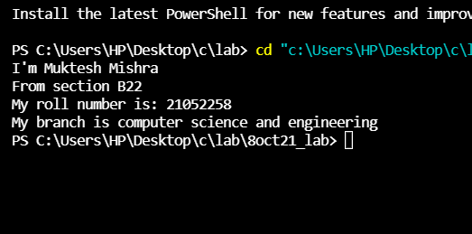

**Program 2:** Write a program to print KIIT in ‘*’ pattern.

Code:

#include<stdio.h>

//Printing KIIT in * format

int main(int argc, char const *argv[])

{

    printf("*  *   ******  ******  *******\n");

    printf("* *      *       *        *\n");

    printf("**       *       *        *\n");

    printf("* *      *       *        *\n");

    printf("*   *  ******  ******     *\n");

    return 0;

}

Output:

